

Lab Report-1

|  |  |
| --- | --- |
| **Course Code** | **Course Title** |
| 0CSE416 | Web Engineering Lab |

|  |  |
| --- | --- |
| **Report Details** | |
| **Experiment Name** | HTML Tags with Description, Attributes, Code, and Output |
| **Submission Date** | 25-05-2025 |

|  |  |
| --- | --- |
| **Submitted To** | **Submitted By** |
| **Nishat Sadaf Lira** Lecturer Department of **CSE**  Daffodil International University | **Tomalika Sarker**  SID : 221-15-5341  Section : 61_J2 Department of **CSE**  Daffodil International University |

**Daffodil International University**

# Tag 1: <html>

* **Description**: Serves as the root container of an HTML document, encompassing all visible and non-visible page elements.
* **Common Attributes**: lang

## Code Snippet:

**<html lang="en"> </html>**

* **Output**: Declares the document structure and language; not visually rendered.
* **Influence**: Serves as the container for all HTML content.

# Tag 2: <head>

* **Description**: Holds metadata, links to stylesheets, scripts, and the page’s title.
* **Common Attributes**: None

## Code Snippet:

**<head> <title>My Website</title> </head>**

* **Output**: No direct visual output; enables the browser to load linked resources.
* **Influence**: Helps browsers and search engines understand the page.

# Tag 3: <title>

* **Description**: Sets the text shown in the browser's title/tab.
* **Common Attributes**: None

## Code Snippet:

**<title>My Website</title>**

* **Output**: Shows “My Website” on the browser tab.



* **Influence**: Improves SEO and user experience

# Tag 4: <meta>

* **Description**: Provides metadata such as character encoding and viewport settings.
* **Code Snippet**:

**<meta charset="UTF-8">**

* **Output**: Not visible; ensures correct character display.

# Tag 5: <link>

* **Description**: Used to link external files like CSS to the HTML document.
* **Code Snippet**:

**<link rel="stylesheet" href="style.css">**

* **Output**: Applies external styles to the webpage.

# Tag 6: <script>

* **Description**: Embeds or links JavaScript code for interactivity.
* **Common Attributes**: src, type
* **Code Snippet:**

**<script>alert("Hi from Tomalika!");</script>**

* **Output**: Renders page content with a light blue background.

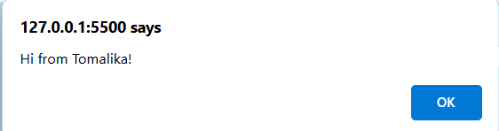

* **Influence**: Everything the user sees is inside <body>.

# 

# 

# Tag 7: <body>

* **Description**: Contains all elements that are visible to the user.
* **Common Attributes**: bgcolor, background, style

## Code Snippet:

**<body bgcolor="lightblue">**

* **Output**: Renders page content with a light blue background.
* **Influence**: Everything the user sees is inside <body>.

# Tag 8: <h1>

* **Description**: Denotes the most important heading on the page.
* **Common Attributes**: id, class, style
* **Code Snippet**:

**<h1 style="color: brown;">Welcome to My Lab</h1>**

* **Output**: Big bold “**Welcome to My Lab**” heading

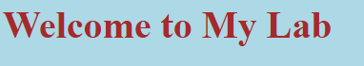

* **Influence:** Marks the main heading of the page, improves structure.

# Tag 9: <h2>

* **Description**: Represents a second-level heading, typically used for subsections.
* **Code Snippet:**

## <h2>Introduction</h2>

* **Output**: Medium-size “**Introduction**” heading



* **Influence:** Organizes content hierarchically.

# Tag 10: <p>

* **Description**: Defines a paragraph block of text.

## Code Snippet:

**<p>This is a paragraph demonstrating HTML basics. Student Name: Tomalika Sarker |**

**ID: 221-15-5341</p>**

* **Output**:



# Tag 11: <a>

* **Description**: Creates hyperlinks to other documents or websites.

## Code Snippet:

## <a href="https://www.google.com" target="_blank" title="Go to Google">Visit Google</a>

* **Output**:



# Tag 12: <img>

* **Description**: Embeds an image from a local or remote source.

## Code Snippet:

## <img src="https://cdn2.hubspot.net/hubfs/53/image8-2.jpg" alt="Sample Logo" width="100" height="100">

* **Output**:



# Tag 13: <br>

* **Description**: Inserts a line break within content.

## Code Snippet:

Line 1<br>

Line 2<br>

* **Output**:
* **Influence**: Helps in line formatting.

# Tag 14: <hr>

* **Description**: Renders a horizontal line for content separation.
* **Code Snippet:**

**<hr>**

* **Output**: A horizontal rule appears across the page.



* **Influence**: Visually separates content.

# Tag 15: <div>

* **Description**: A block-level container for grouping elements.
* **Code Snippet:**

**<div style="color:brown;">This is a brown text inside a DIV.</div>**

* **Output**:



* **Influence**: Helps in layout and styling.

# Tag 16: <span>

* **Description**: An inline container used for styling text without breaking flow.
* **Code Snippet:**

## <p>This is a <span style="color:purple;">purple</span> word using span tag.</p>

* **Output**:

## 

* **Influence**: Applies styles without breaking lines.

# Tag 17: <ul>

* **Description**: Creates an unordered list of bullet points.

## Code Snippet:

## 

## <ul type="disc">

## <li>Unordered Item 1</li>

## <li>Unordered Item 2</li>

## </ul>

* **Output**:



* **Influence**: Used for lists with no order.

# Tag 18: <ol>

* **Description**: Constructs an ordered (numbered) list.

## Code Snippet:

## <ol type="1">

## <li>Ordered Step 1</li>

## <li>Ordered Step 2</li>

## </ol>

* **Output**:

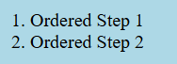

* **Influence**: Helpful in instructions/steps.

# Tag 19: <li>

* **Description**: Defines each item in a list.
* **Code Snippet:**

**<li>Ordered Step 1</li>**

* **Output**:



* **Influence**: Makes up list content.

# Tag 20: <table>

* **Description**: Creates a table for organizing content in rows and columns.
* **Common Attributes**: border, cellpadding, cellspacing

## Code Snippet:

## <table border="1" cellpadding="5" cellspacing="0">

**Output**:

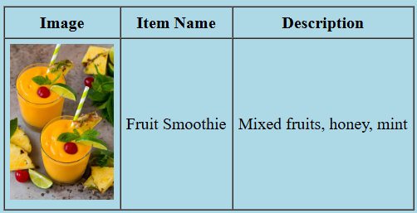

**Influence**: Organizes data in rows and columns.

# Tag 21: <tr>

* **Description**: Represents a row in a table.
* **Code Snippet:**

## <tr>

## <th>Image</th>

## <th>Item Name</th>

## <th>Description</th>

## </tr>

* **Output**: A single row is added to the table layout.



* **Influence**: Used to define each row in a table.

# Tag 22: <td>

* **Description**: Represents a standard data cell within a table row.
* **Code Snippet:**

**<tr>**

**<td><img src="https://www.dinneratthezoo.com/wp- content/uploads/2016/08/tropical-smoothie-14.jpg" alt="Fruit Smoothie" width="100"></td>**

**<td>Fruit Smoothie</td>**

**<td>Mixed fruits, honey, mint</td>**

**</tr>**

* **Output**: Displays content inside a table cell.

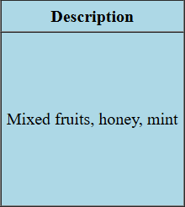

* **Influence**: Holds the actual data inside a table.

# Tag 23: <th>

* **Description**: Defines a header cell in a table.
* **Code Snippet:**

**<th>Image</th>**

**<th>Item Name</th>**

**<th>Description</th>**

* **Output**: Bold and centered text in a table header.



* **Influence**: Labels columns/rows, improves readability.

# Tag 24: <form>

# Description: Creates a form for user input submission.

# Attributes: action, method

* **Code Snippet**:

**<form action="/submit" method="post">**

**<label for="username">Username:</label>**

**<input type="text" name="username" placeholder="Enter your username" required>**

**<br><br>**

**<button type="submit">Submit</button>**

**</form>**

* **Output**: Renders a blank form container.

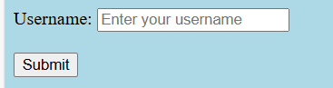

* **Influence**: Accepts user input.

# Tag 25: <label>

* **Description**: Provides a descriptive label for form inputs.
* **Code Snippet:**

**<label for="username">Username:</label>**

* **Output**:



* **Influence**: Improves accessibility.

# Tag 26: <input>

* **Description**: Accepts user input in various formats like text, radio, etc.
* **Attributes**: type, name, value
* **Code Snippet:**

**<input type="text" name="username" placeholder="Enter your username" required>**

* **Output**: Text input box



* **Influence**: Allows user to enter data.

# Tag 27: <button>

* **Description**: Adds a button element for form submission or actions.
* **Code Snippet:**

**<button type="submit">Submit</button>**

* **Output**:



* **Influence**: Triggers actions.

# Tag 28: < select>

* **Description**: Creates a drop-down list menu.
* **Code Snippet:**

**<select name="dropdown">**

**<option value="1">Option 1</option>**

**<option value="2">Option 2</option>**

**</select>**

* **Output**:



# Tag 29: <option>

* **Description:** Specifies individual options in a drop-down list.
* **Code Snippet**:

**<option value="1">Option 1</option>**

**<option value="2">Option 2</option>**

* **Output**:

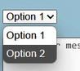

# Tag 30: < textarea>

* **Description**: Provides a field for multi-line text input.

## Code Snippet:

<**textarea rows="4" cols="30" placeholder="Enter your message here...">**

**</textarea>**

* **Output**:

